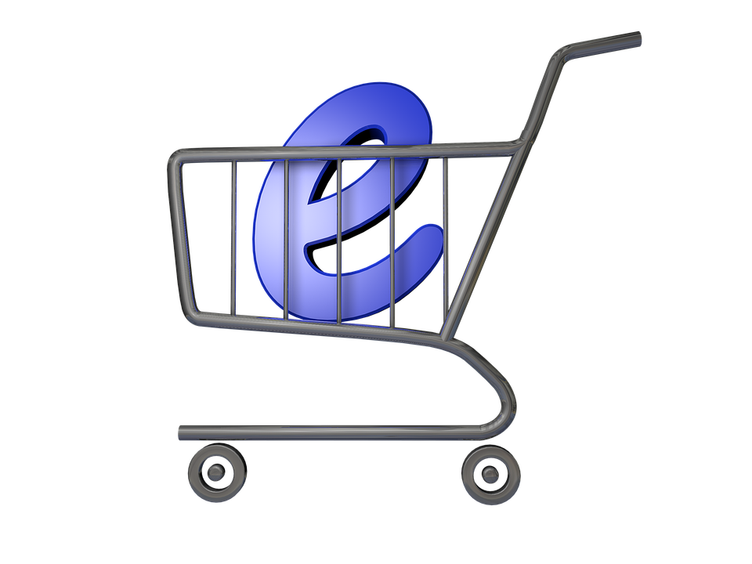

**SHOPME E-COMMERCE**

**PREFACE**

E-commerce as anything that involves an online transaction. E-commerce provides multiple benefits to the consumers in form of the availability of goods at lower cost, wider choice and saves time. The general category of e-commerce can be broken down into two parts: E-merchandise: E-finance. E commerce involves conducting business using modern communication instruments: telephone, fax, e-payment, money transfer systems, e-data interchange and the Internet. Online businesses like financial services, travel, entertainment, and groceries are all likely to grow. Forces influencing the distribution of global e-commerce and its forms include economic factors, political factors, cultural factors and supranational institutions.

It has an impact over the economy of many countries among which India is on the top of that list. It has named as new gold rush in e-commerce. E-commerce has many reasons that why it is very crucial in developing the country . For the study we have taken several parts of the world such as North America , Latin America , Europe , Middle-East , Africa and South Asia ,and Australia. E-commerce has an intent to bring some transformation in the society and that’s the reason its essential for the B2B and B2C commerce .

**RESEARCH OBJECTIVES**

The study is focused on the achievement of the following objectives:

* To assess the latest trend in e-commerce globally.
* The impact of growth of e-commerce.
* To analyze the latest global scenario of e-commerce.
* The impact of growth on the overall economy.

**INTRODUCTION:**

Here, you'll find everything you need about Shopme, a simple yet powerful e-commerce website built with Spring Boot and Bootstrap. Our documentation is your comprehensive guide to understanding and utilizing every aspect of the Shopme project.

Whether you're a beginner looking to learn the basics of Spring Boot and Bootstrap or a seasoned developer seeking to explore the intricacies of our e-commerce platform, you'll find valuable information tailored to your needs.

From installation instructions to in-depth explanations of key features, from troubleshooting tips to best practices for customization, our documentation covers it all. You'll also find code examples, tutorials, and frequently asked questions to help you make the most of your Shopme experience.

At Shopme, we believe in empowering our users with the knowledge and resources to succeed. That's why we've put together this comprehensive documentation, designed to support you every step on your journey with Shopme.

So, whether you're just getting started or already knee-deep in code, dive into our documentation, explore all that Shopme has to offer, and unleash your creativity in the world of e-commerce development.

**ABSTRACT**:

The Shopme E-commerce Documentation serves as a comprehensive resource for developers embarking on the journey of mastering Spring Boot and Bootstrap by creating an e-commerce website. This document covers a wide range of topics essential for understanding and implementing the Shopme project, including installation procedures, configuration options, and deployment considerations. It delves into the core functionalities of the Shopme platform, such as user management, product catalog management, shopping cart functionality, and order processing. Furthermore, the documentation explores advanced features such as security measures, database integration, and RESTful API implementation. Rich with code snippets, diagrams, and practical examples, it provides hands-on guidance for developers at every level of expertise. Additionally, the documentation addresses common challenges and troubleshooting techniques, ensuring a smooth learning experience. Whether you're a novice developer seeking to grasp the fundamentals of web development or a seasoned professional aiming to expand your skill set, Shopme Ecommerce Documentation equips you with the knowledge and confidence to build robust and scalable e-commerce applications.

**History of E-commerce**

***Concerning Technology***

E-commerce began before personal computers were prevalent and has grown into a multi-billion dollar industry. The meaning of the term "electronic commerce" has changed over the last 30 years. Originally, "electronic commerce" meant the facilitation of commercial transactions electronically, usually using technology like Electronic Data Interchange (EDI) and Electronic Funds Transfer (EFT), where both were introduced in the late 1970s, for example, to send commercial documents like purchase orders or invoices electronically.

The 'electronic' or 'e' in e-commerce refers to the technology/systems; the 'commerce' refers to be traditional business models. E-commerce is the complete set of processes that support commercial business activities on a network. In the 1970s and 1980s, this would also have involved information analysis. The growth and acceptance of credit cards, automated teller machines (ATM) and telephone banking in the 1980s were also forms of e-commerce. However, from the 1990s onwards, this would include enterprise resource planning systems (ERP), data mining and data warehousing.

In the dot com era, it came to include activities more precisely termed "Web commerce" - the purchase of goods and services over the World Wide Web, usually with secure connections (HTTPS, a special server protocol that encrypts confidential ordering data for customer protection) with e-shopping carts and with electronic payment services, like credit card payment authorizations.

Today, it encompasses a very wide range of business activities and processes, from e-banking to offshore manufacturing to e-logistics. The ever growing dependence of modern industries on electronically enabled business processes gave impetus to the growth and development of supporting systems, including backend systems, applications and middleware. Examples are broadband and fibre-optic networks, supply-chain management software, customer relationship management software, inventory control systems and financial accounting software.

**Concerning Decisions/Foot steps**

When the Web first became well-known among the general public in 1994, many journalists and pundits forecast that e-commerce would soon become a major economic sector. However, it took about four years for security protocols (like HTTPS) to become sufficiently developed and widely deployed. Subsequently, between 1998 and 2000, a substantial number of businesses in the United States and Western Europe developed rudimentary web sites.

Although a large number of "pure e-commerce" companies disappeared during the dot-com collapse in 2000 and 2001, many "brick-and-mortar" retailers recognized that such companies had identified valuable niche markets and began to add e-commerce capabilities to their Web sites. For example, after the collapse of online grocer Webvan, two traditional supermarket chains, Albertsons and Safeway, both started e-commerce subsidiaries through which consumers could order groceries online.

The emergence of e-commerce also significantly lowered barriers to entry in the selling of many types of goods; accordingly many small home-based proprietors are able to use the internet to sell goods. Often, small sellers use online auction sites such as EBay, or sell via large corporate websites like Amazon.com, in order to take advantage of the exposure and setup convenience of such sites.

**CONCEPTUAL FRAMEWORK**

**Mobile technologies** – More people access the Internet on their mobile devices than on any other device. We are rapidly approaching the time (if we are not already there) where designs must be created for the mobile Web first, and for the desktop second.  Mobile technologies facilitate comparison shopping; with the advent of barcode reader apps and price-comparison databases, a consumer could snap a bar code in Walmart and quickly reference product reviews and prices on walmart.com (or compare prices with Walmart competitors).  Mobile technologies also facilitate impulse buys – especially with the advent of micro-payments tied to the mobile device.  Just recently,  Starbucks customers can not only place an order with their Smartphone, but also make a purchase.

**FUNCTION:**

1. Enable customers to buy online.

2. Enable customers to easily browse through the products.

3. Enable customers to search for products.

4. allowing customers to post queries and discuss products and self through us.

5. allow the businessman to manage the shop inventory.

6. allow the businessman to view graphs depicting previous sales etc.

7. allow the businessman to change the look and feel of the site with ease.

8. allow the shopkeeper to view different configuration options and update them.

**LOGIN PAGE:**

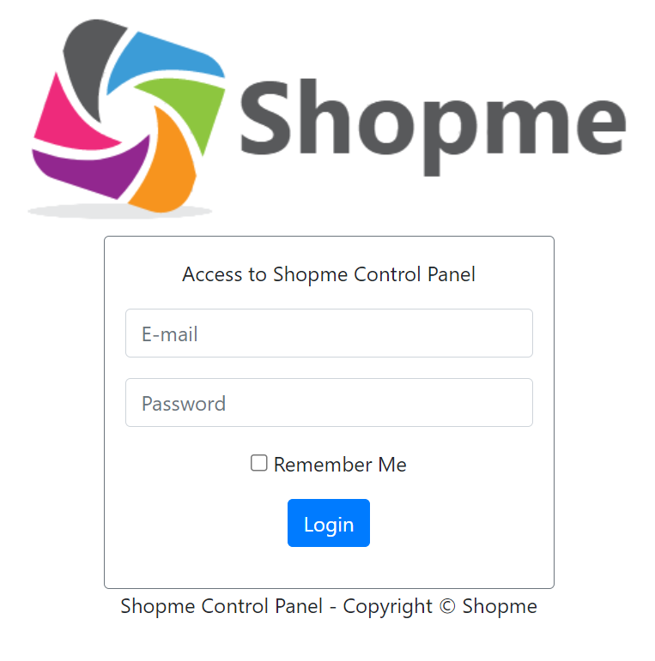

The provided context appears to be the content for a login page image, specifically for a system called Shopme. The image would likely contain the following elements:

**Shopme Control Panel:**

The title of the page indicates that this is the login page for accessing the control panel of the Shopme system.

**E-mail:**

A form field where users enter their email address associated with their Shopme account.

**Password:**

A form field where users enter their password associated with their Shopme account.

**Remember Me:**

A checkbox that, when selected, allows the user's login credentials to be stored in their browser for easier access in the future.

**Login:**

A button that, when clicked, submits the entered email and password for verification and grants access to the Shopme Control Panel if the credentials are correct.

**Copyright © Shopme:**

A notice indicating the ownership and copyright of the Shopme system.

**DATABASE MODEL:**

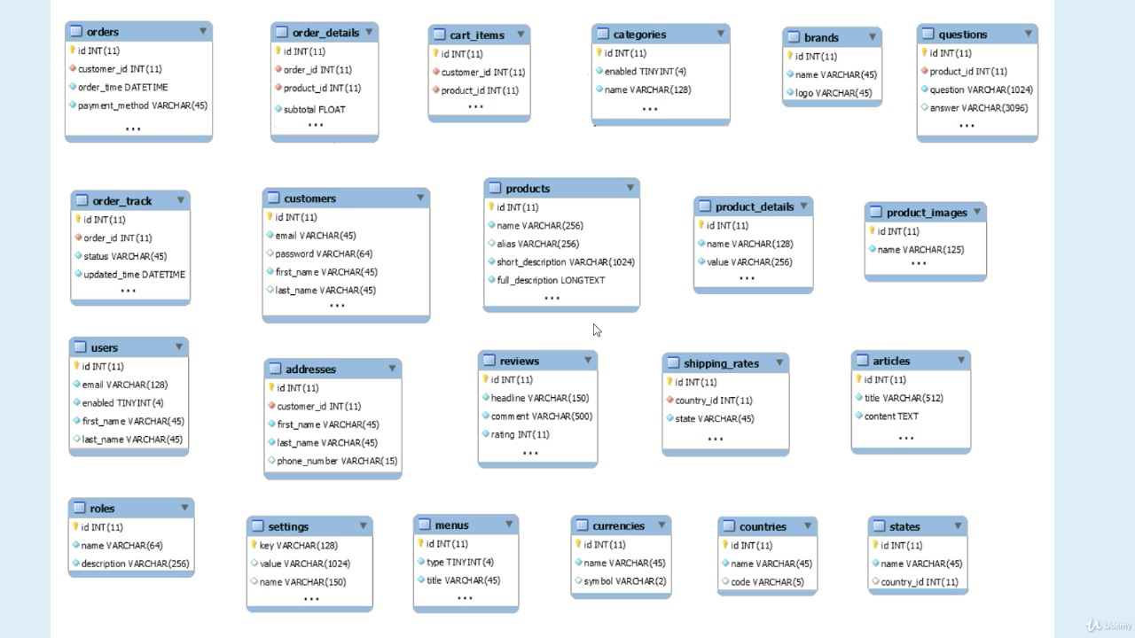

**NAVBAR:**

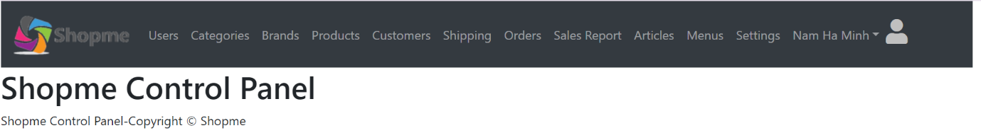

**Shopme Logo:**

The logo of the Shopme website would be located on the left side of the navbar. Clicking on the logo would likely take users back to the homepage.

**Users:**

A dropdown menu that allows users to access their account-related features, such as their order history, account settings, and sign-in/sign-up options.

**Categories:**

A drop-down menu that lists the main categories of products available on the Shopme website. Users can click on a category to view the products within that category.

**Brands:**

A drop-down menu that lists the brands available on the Shopme website. Users can click on a brand to view the products from that brand.

**Products:**

A link to the products page, where users can view all the products available on the Shopme website.

**Customers:**

A link to the customers page, where shop owners can view and manage their customer information.

**Shipping:**

A link to the shipping page, where shop owners can view and manage shipping information for their products.

**Order:**

A link to the order page, where shop owners can view and manage their orders.

**Sales Report:**

A link to the sales report page, where shop owners can view and analyze their sales data.

**Articles:**

A link to the articles page, where users can view and read articles related to the products or the industry.

**Menus:**

A dropdown menu that allows users to access different menus, such as the main menu, footer menu, or mobile menu.

**Settings:**

A dropdown menu that allows users to access the website settings, such as language, currency, or time zone.

**Login Person Profile:**

A link to the user's profile page, where they can view and edit their personal information, such as their name, email, or password.

**Roles DB:**

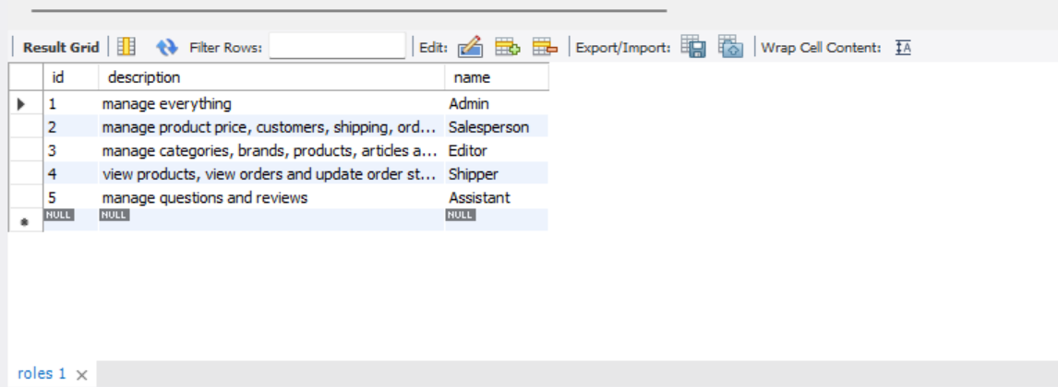

It can provide a detailed description of the table in the steps:

The table has three columns: "id", "description", and "name".

The table has five rows of data, each representing a different role.

* The first row (id: 1) represents the **"Admin"** role, which has the description "manage everything".
* The second row (id: 2) represents the **"Salesperson"** role, which has the description "manage product price, customers, shipping, orders".
* The third row (id: 3) represents the **"Editor"** role, which has the description "manage categories, brands, products, articles".
* The fourth row (id: 4) represents the **"Shipper"** role, which has the description "view products, view orders and update order status".
* The fifth row (id: 5) represents the **"Assistant"** role, which has the description "manage questions and reviews".

**ADMIN:**

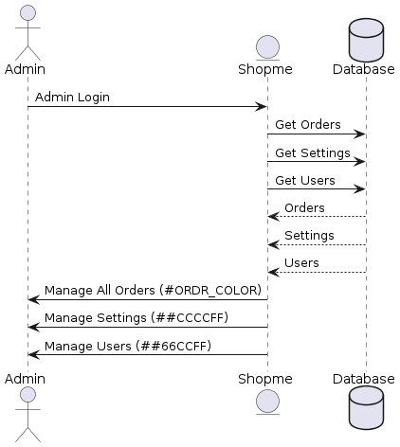

**EDITOR:**

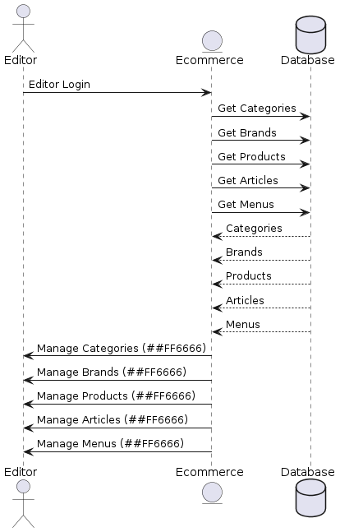

**SALES PERSON:**

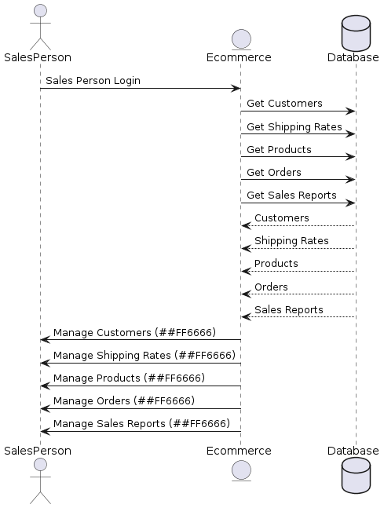

**Shipper:**

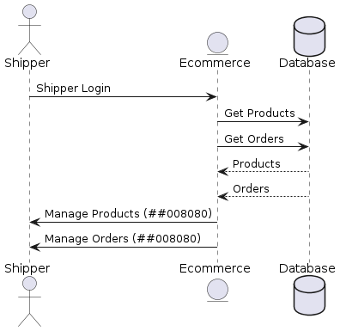

**ASSISTANCE:**

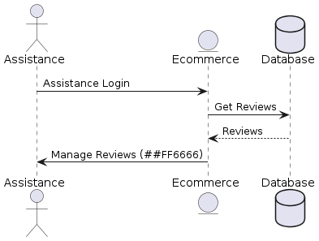

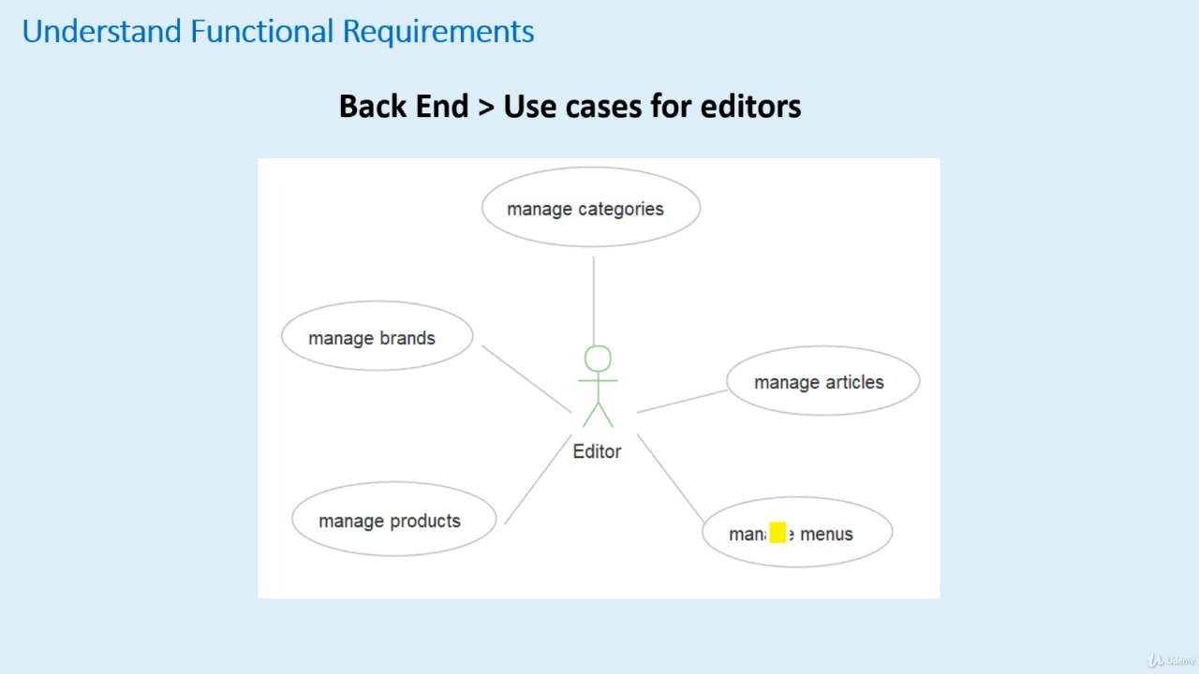

**USERS:**

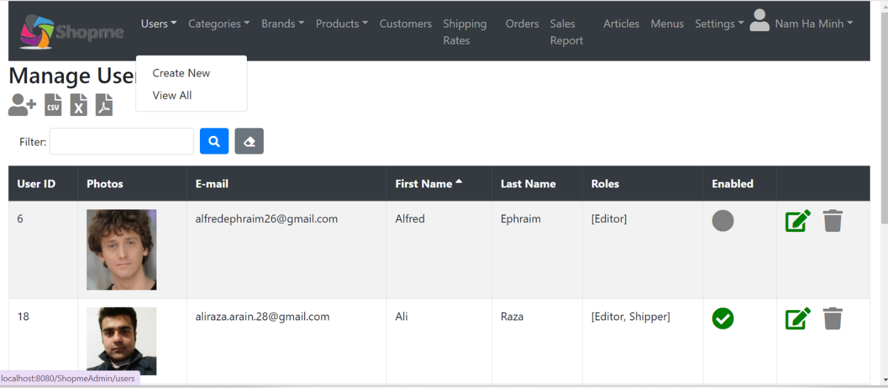

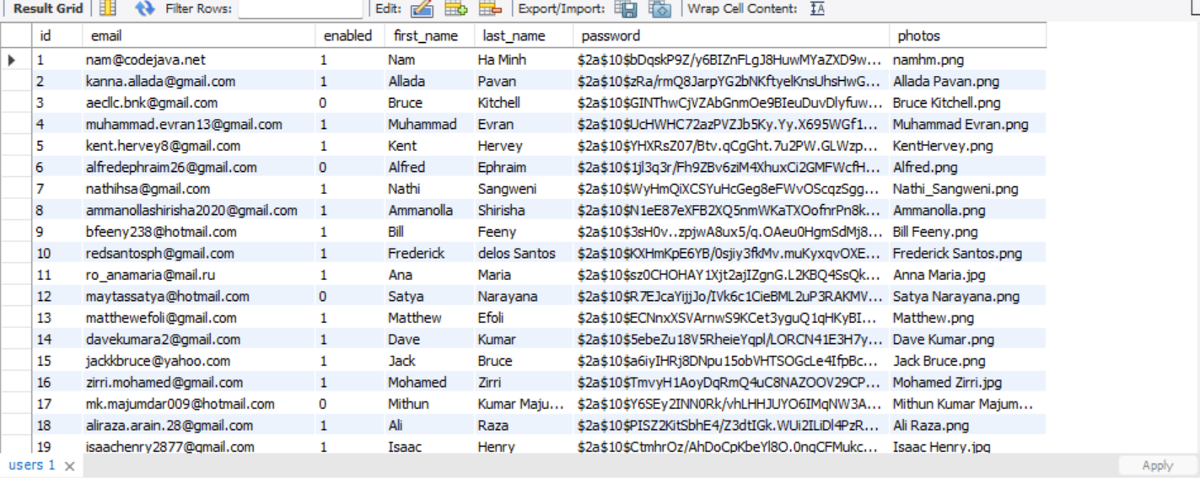

The table appears to have the following columns:

**ID:** A unique identifier for each record in the table.

**Product Name:** The name of the product.

**Category:** The category to which the product belongs.

**Brand:** The brand that manufactures or sells the product.

**Price:** The price of the product.

**Quantity:** The quantity of the product in stock.

**Description:** A brief description of the product.

**Image:** An image of the product.

**The table also appears to have the following features:**

**Sorting:**

Users can click on the column headers to sort the table by that column. The arrow next to the column header indicates the direction of the sort.

**Pagination:**

The table is divided into multiple pages, with a dropdown menu to select the number of records per page and navigation buttons to move between pages.

**Search:**

Users can enter a search term in the search box to filter the table by that term.

**Action buttons:**

Each row in the table has a set of action buttons, including Edit, Delete, and View, which allow users to perform various actions on the record.

**USER ROLES DB:**

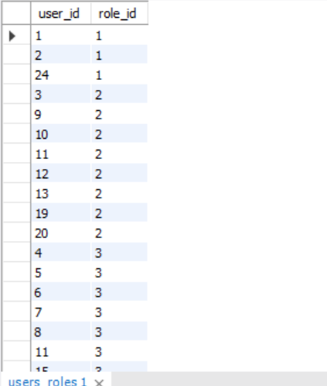

**Categories:**

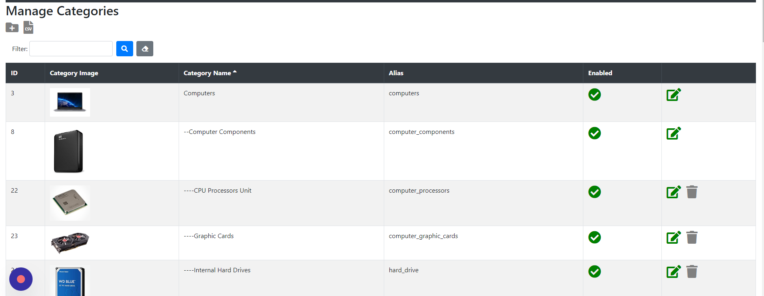

The image contains a table or a list of categories related to computer components with the following details:

**ID:**

A unique identifier assigned to each category.

**Category Image:**

A visual representation or icon associated with each category.

**Category Name:**

The name of the category, which is self-explanatory.

**Alias:**

A shortened or alternative name for the category.

**Computers:**

This category includes subcategories of computer components.

**Computer Components:**

This is a subcategory of Computers, which includes further subcategories of computer components.

**CPU Processors Unit:**

This is a subcategory of Computer Components, which refers to the central processing unit of a computer.

**Enabled:**

This indicates whether the category is currently active or not. In this case, all categories are enabled.

**Categories db:**

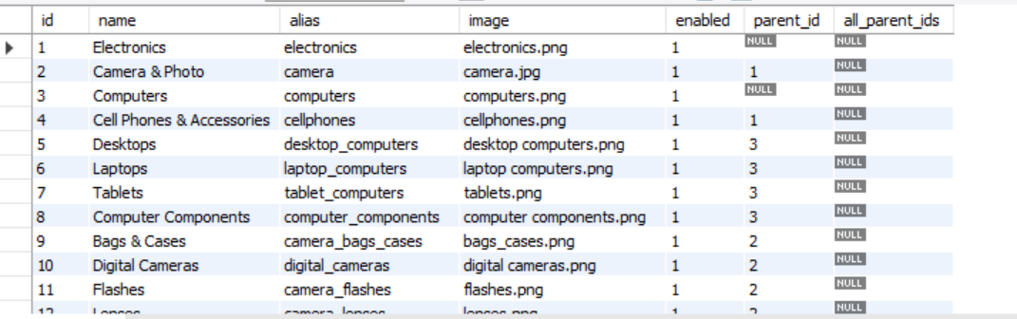

**BRANDS:**

ShopMe's brand management system is designed to provide a comprehensive and organized approach to managing the various brands featured on the platform. Each brand in ShopMe is characterized by specific attributes stored in the database, including a unique **Brand ID** to identify the brand, a **Logo** to visually represent the brand, and the **Brand Name** that officially identifies the brand. To further facilitate organization and navigation, each brand is also associated with a **Category** that the brand belongs to.

To ensure administrative control over the brands, ShopMe offers **Enable, Edit, and Delete Options** that allow authorized users to enable or disable brands, as well as edit and delete them as needed. This functionality empowers the platform's administrators to maintain a curated and up-to-date selection of brands, ensuring a seamless and engaging shopping experience for customers.

1. Brand Attributes:

Brand ID: A unique identifier assigned to each brand within the system, enabling easy reference and management.

Logo: A visual representation of the brand, aiding in brand recognition and visual appeal on the platform.

Brand Name: The official name by which the brand is known and identified, providing clarity and consistency across the platform.

Category: Each brand is associated with a specific category, helping users to browse and discover brands based on their interests and preferences.

2. Administrative Controls:

Enable: Administrators can enable or activate brands, making them visible and accessible to users on the platform.

Edit: Authorized users have the ability to modify brand attributes such as the brand name, logo, and category, ensuring accurate and up-to-date information.

Delete: Administrators can remove brands from the platform if necessary, maintaining a curated selection of brands and ensuring a clutter-free user experience.

3. Importance of Brand Management:

Consistency: By maintaining consistent brand attributes and information, ShopMe enhances brand recognition and builds trust among customers.

Organization: A well-structured brand management system facilitates efficient organization and navigation, enhancing the overall user experience.

Quality Control: The ability to enable, edit, and delete brands allows administrators to uphold quality standards and ensure that only reputable brands are featured on the platform.

4. User Experience:

Seamless Navigation: Users can easily browse and discover brands within their preferred categories, enhancing engagement and satisfaction.

Up-to-Date Content: Regular updates and edits to brand information ensure that users have access to the latest offerings and promotions.

Trust and Reliability: By maintaining a curated selection of brands, ShopMe instills confidence in users, leading to increased customer loyalty and retention.

5. Future Enhancements:

Advanced Filtering: Implementing advanced filtering options based on brand attributes and categories to further enhance the browsing experience.

User Feedback Integration: Incorporating user feedback mechanisms to gather insights and improve brand selection and management.

Integration with Analytics: Utilizing analytics tools to track user interactions and preferences, enabling data-driven decisions for optimizing the brand management system.

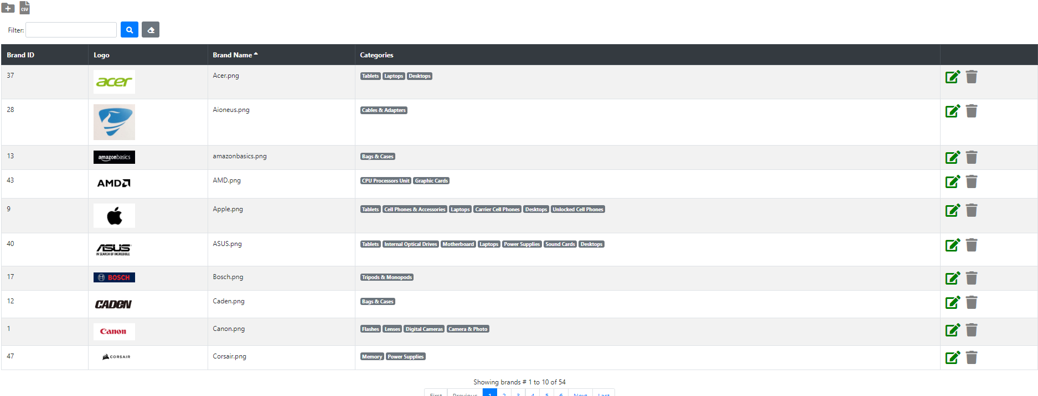

**PRODUCTS:**

Each product in ShopMe is characterized by key attributes stored in the database. These attributes include a unique **ID** to identify the product, a **Main Image** to provide a visual representation of the product and attract users, and a **Product Name** that offers a descriptive name identifying the product. Additionally, each product is associated with a **Brand** for brand recognition, and a **Category** to which the product belongs, aiding in classification and organization.

To ensure administrative control over the products, ShopMe offers **Enable, Edit, and Delete Options** that allow authorized users to enable or disable products, as well as edit and delete them as needed. This functionality empowers the platform's administrators to maintain a curated and up-to-date selection of products, ensuring a seamless and engaging shopping experience for customers.

1. Product Attributes:

Product ID: A unique identifier assigned to each product within the system, facilitating easy referencing and management.

Main Image: A visually appealing representation of the product, serving as a primary tool for attracting users and showcasing the product's features.

Product Name: A descriptive name that accurately identifies the product, aiding users in understanding its purpose and characteristics.

Brand: Each product is associated with a specific brand, enabling brand recognition and fostering trust among users.

Category: Products are categorized based on their attributes and purpose, helping users navigate and discover products of interest more efficiently.

2. Administrative Controls:

Enable: Administrators can enable or activate products, making them visible and available for purchase on the platform.

Edit: Authorized users have the ability to modify product attributes such as the product name, main image, brand, and category, ensuring accurate and up-to-date information.

Delete: Administrators can remove products from the platform if necessary, maintaining a curated selection of products and enhancing the overall shopping experience.

3. Importance of Product Management:

User Experience: A well-managed product catalog ensures a seamless and engaging shopping experience for customers, leading to increased satisfaction and loyalty.

Visibility: By enabling products and maintaining high-quality main images, ShopMe enhances the visibility of products, attracting more users and driving sales.

Organization: Effective product categorization and management aid in organizing the platform's inventory, making it easier for users to find products relevant to their interests and needs.

4. Quality Control:

Accuracy: Regular editing and updates to product attributes ensure that product information remains accurate and up-to-date, minimizing user confusion and dissatisfaction.

Reputation Management: By maintaining a curated selection of products, ShopMe upholds its reputation as a reliable and trustworthy shopping destination, fostering customer trust and loyalty.

Brand Integrity: Associating products with reputable brands enhances brand integrity and credibility, reinforcing ShopMe's commitment to offering high-quality products to its users.

5. Future Enhancements:

Product Reviews: Integrating a product review system to gather user feedback and improve product selection and quality.

Recommendation Engine: Implementing a recommendation engine based on user preferences and browsing history to personalize the shopping experience and increase sales.

Enhanced Search Functionality: Improving search functionality to allow users to easily find products by name, brand, category, or other relevant attributes.

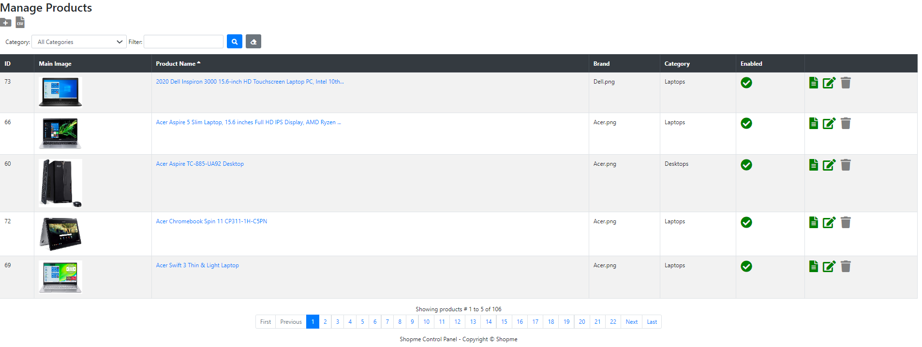

**CUSTOMERS:**

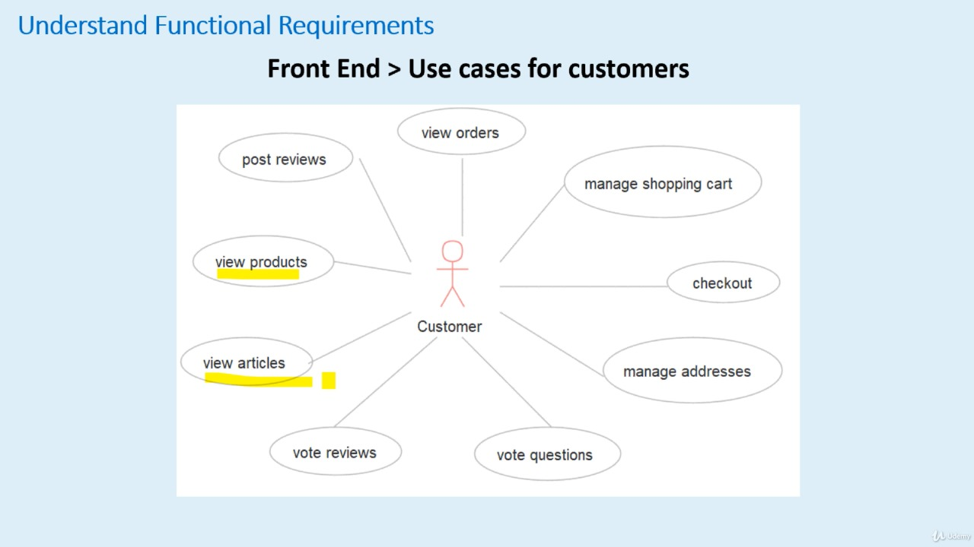

**The system has several features for customers, including:**

Viewing orders

Posting reviews

Viewing products

Managing shopping cart

Checking out

Viewing articles

**The explain the six features for customers in more detail:**

Viewing orders: This feature allows customers to view their past orders and their details, such as the items ordered, the quantity, the price, and the delivery status.

Posting reviews: Customers can post reviews for products they have purchased. This feature allows them to share their thoughts and opinions about the product with other customers, which can help them make informed purchasing decisions.

Viewing products: This feature allows customers to browse and view the products available for purchase. They can see the product name, description, price, and images.

Managing shopping cart: Customers can add products to their shopping cart and manage the items in their cart, such as updating the quantity or removing items.

Checking out: This feature allows customers to complete their purchase by providing their shipping and payment information.

Viewing articles: Customers can view articles related to the products or services offered by the system. These articles can provide additional information and context to help customers make informed decisions.

**SALES:**

**Overview**

ShopMe provides comprehensive sales reports to help users analyze their business performance and make informed decisions. These reports cover sales data by date, category, and product, allowing users to identify trends, pinpoint areas for improvement, and optimize their strategies.

**Sales by Date**

The Sales by Date report visualizes sales data over time, enabling users to track performance trends, identify seasonal patterns, and analyze fluctuations in sales volume. By examining sales trends over different time intervals, users can gain insights into consumer behavior and plan their marketing and inventory strategies accordingly.

**Sales by Category**

The Sales by Category report breaks down sales figures by product categories, offering insights into which categories are performing well and which ones may require attention. By highlighting top-performing categories and areas for growth or improvement, this report helps users optimize their product offerings, marketing efforts, and inventory management strategies.

**Sales by Product**

The Sales by Product report provides detailed insights into the performance of individual products, including best-selling items, slow-moving inventory, and opportunities for optimization. By identifying top-performing products and analyzing their sales patterns, users can make data-driven decisions about pricing, promotions, and inventory management to maximize profitability.

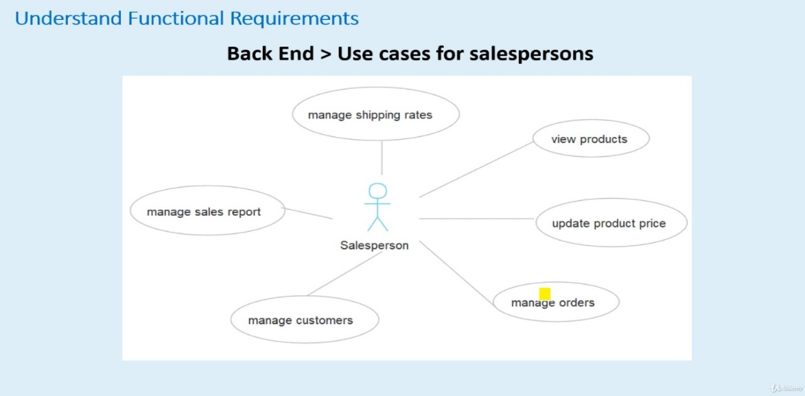

**FRONTEND:**

**The page contains various elements, including:**

**Navigation Menu**

* Shopme Careers
* Payments
* Shipping & Delivery
* Login
* Register
* Contact

**Search Bar**

* A search input field with a placeholder text "keyword"
* A search button

**Categories**

* A list of categories, including:
  + Memory
  + Bags & Cases
  + Cables & Adapters
  + Carrier Cell Phones
  + Cases
  + CPU Processors
  + Graphic Cards
  + Desktops
  + Digital Cameras
  + Flashes
  + Headphones
  + Unit
  + Internal Hard Drives
  + Internal Optical Drives
  + Laptops
  + Lenses
  + Motherboard
  + Network Cards
  + Solid State Drives
  + Sound Cards
  + MicroSD Cards
  + Power Supplies
  + Stands
  + Tablets
  + Tripods & Monopods
  + Unlocked Cell Phones

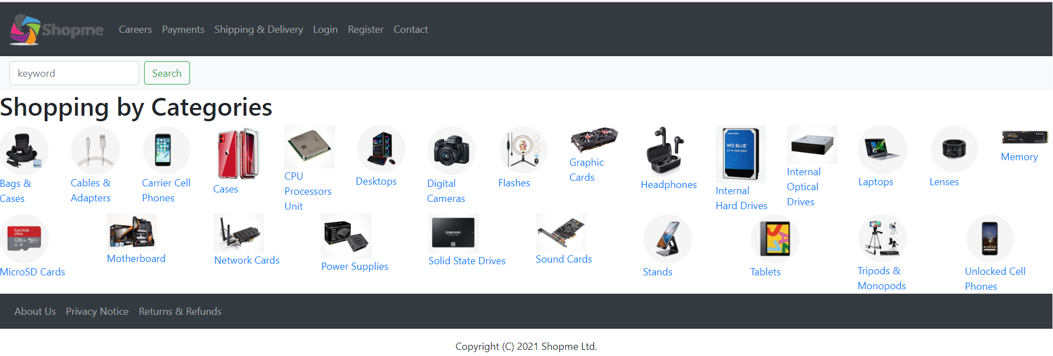

**HOMEPAGE:**

The registration form will contain the following things.

* + First Name
  + Last Name
  + E-mail
  + Password (and re-type password for confirmation)
  + Phone Number
  + Address Line 1
  + Address Line 2 (optional)
  + City
  + Country
  + State/Province
  + Postal Code
* After filling in all the required details, ensure that the "Enabled" checkbox is checked.
* Click on the "Create Account" button to submit your registration request.

Upon successful registration, you will be able to log in to your Shopme account and start enjoying our services.

**CUSTOMER LOGIN:**

The following options for a customer login page:

* Continue with Google
* Continue with Facebook
* E-mail
* Password
* Remember Me
* Login
* Forgot Password
* Don't have an account? Sign up

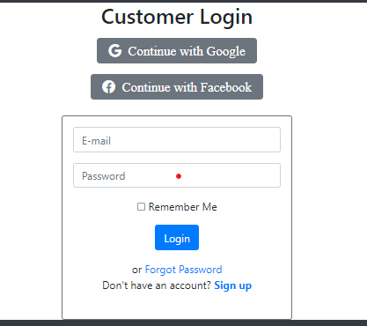

**Continue with Google:**

This option allows customers to log in using their Google account. When they click on this option, they will be redirected to a Google sign-in page where they can enter their Google account credentials. Once they have successfully logged in, they will be redirected back to the website and automatically logged in.

**Continue with Facebook:**

This option allows customers to log in using their Facebook account. When they click on this option, they will be redirected to a Facebook sign-in page where they can enter their Facebook account credentials. Once they have successfully logged in, they will be redirected back to the website and automatically logged in.

**E-mail:**

This option allows customers to log in using their email address. When they click on this option, they will be prompted to enter their email address and password. Once they have entered their credentials, they can click on the "Login" button to log in.

**Password:**

This option allows customers to enter their password. When they click on this option, they will be prompted to enter their email address and password. Once they have entered their credentials, they can click on the "Login" button to log in.

**Remember Me:**

This option allows customers to save their login credentials on their device. When they check this box, their email address and password will be saved on their device, and they will be automatically logged in the next time they visit the website.

**Login:**

This option allows customers to log in to their account. When they click on this option, they will be prompted to enter their email address and password. Once they have entered their credentials, they can click on the "Login" button to log in.

**Forgot Password:**

This option allows customers to reset their password if they have forgotten it. When they click on this option, they will be prompted to enter their email address. Once they have entered their email address, they will receive an email with instructions on how to reset their password.

**Don't have an account? Sign up:**

This option allows customers to create a new account. When they click on this option, they will be redirected to a sign-up page where they can enter their personal information and create a new account.

**CUSTOMER:**

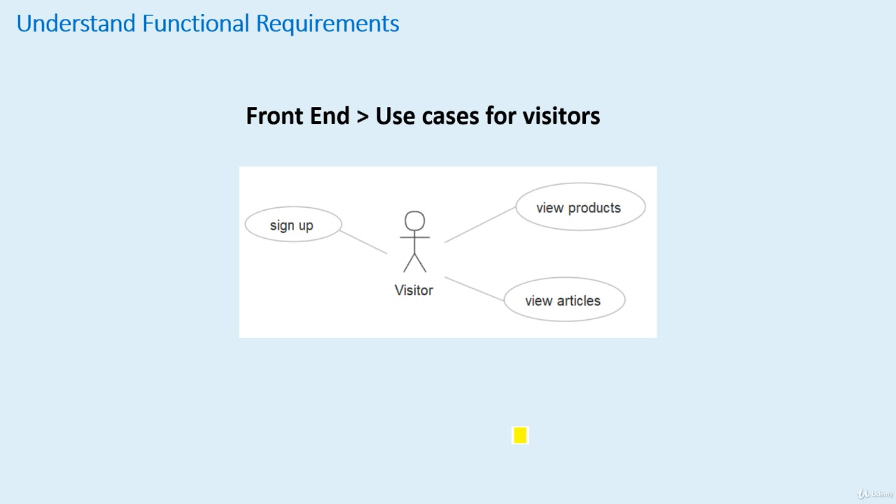

**Here is a summary of the features:**

**Viewing orders:** Customers can view their past orders and their details, such as the items ordered, the quantity, the price, and the delivery status.

**Posting reviews:** Customers can post reviews for products they have purchased, sharing their thoughts and opinions with other customers.

**Viewing products:** Customers can browse and view the products available for purchase, seeing the product name, description, price, and images.

**Managing shopping cart:** Customers can add products to their shopping cart and manage the items in their cart, such as updating the quantity or removing items.

**Checking out:** Customers can complete their purchase by providing their shipping and payment information.

**Viewing articles:** Customers can view articles related to the products or services offered by the system, providing additional information and context.

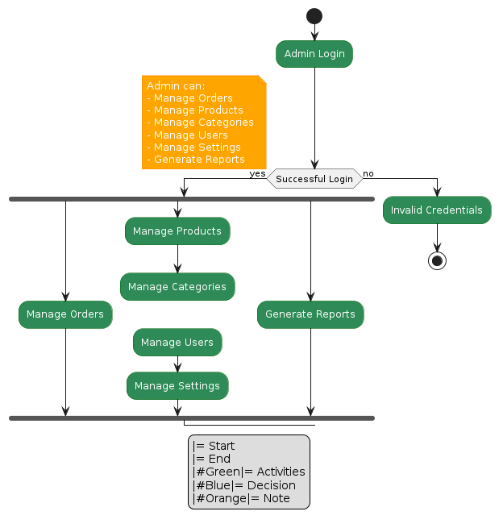

**KEY REASONS FOR THE SUCCESS OF E-COMMERCE**

* **Shopping 24x7**: E-commerce facilitates shopping anytime, anywhere and for almost anything desired. Busy consumers prefer this to the restrictions of when a mall/shop is open and the need to physically travel to a shop. Online business takes shopping a step further by taking itself to the customer creating conveniences of shopping anywhere and at any time.
* **Reduced operational cost:** Since the entire business can be moved online, the need for physical stores has become obsolete. Less infrastructural investment and associated labour costs drives up the profit margin. The seller can then transfer this benefit to the customer in the form of discounted pricing which boosts the appeal of online shopping**.**
* **Easy to compare:** It is far easier and quicker to compare prices of goods online, equipping the customer with the information to decide the right price or terms for themselves. The comparison is not restricted to items from a single seller, or a single region. One can explore products across global markets via e commerce.
* **Safe & secure**:Customers can trust the process of going online and purchasing only when transactions are fast, convenient and secure. A high degree of integrity is possible only when the online electronic payment provider is reputable and trustworthy. In India, all payment transaction providers are required to comply with the security requirements laid out by the Reserve Bank of India making the system more robust and reliable.
* **Increased reach for the merchant**: Just as the customer finds them able to venture across geographic markets, the merchant too is able to display his product to customers in new territories. Market penetration also becomes far more achievable with e-commerce; it is possible for a merchant in Mumbai to extend his reach to north-eastern cities or even rural villages that are now connected by the online network.
* **Social media trend**: In India, with the increasing propensity of social media, businesses have now begun to engage their customers on social networking portals such as Facebook. Promotions, sales and new products are increasingly showcased through such channels and mobile apps are now available that suggest products to users based on their profiles. These are likely to be rapidly developing marketing channels for the future.

The e-commerce world is changing rapidly in the digitized world. These e-commerce developments may have been accelerated by the global economic downturn which may be driving consumers to find new ways of reducing their costs of living. The online channel offers a clear value proposition for both merchants and consumers making it the most sought after and exciting business model today

**SUMMARY**

The Internet is dramatically expanding opportunities for business-to-business (B2B), Business-to-consume ( B 2 C ) E-commerce transactions across borders. For B2Ctransactions especially, the Internet sets up a potential revolution in global commerce: the individualization of trade. It gives consumers the ability to conduct a transaction directly with a foreign seller without traveling to the seller’s country. While this could be done in the past by post, telegram, phone, or fax, such sales were relatively rare because the consumer had to know in advance where to make contact and what to buy. The Interne t al lows sellers to put their storefronts, in the form of Web pages, in front of consumers all over the world. Technology has expanded t h e consumer marketplace to an unprecedented degree, and it will change the way we think about trade. The implications of this for economic development, globalization, and cultural exchange are immense . This creates opportunities for both consumers and small enterprises that must not be squandered. But for all the potential of global e-commerce, there are countless vexing policy questions to be worked out, any one of which can threaten the viability of this nascent form of trade. All of the Internet issues being debated in the United States—consumer protect ion, data privacy, taxation, content regulation, copyright, spam, technology deployment , and many more—need to be resolved at the international level as well .

However, unlike the United States ,which has a federal government and a constitutional guarantee of free trade, global ecommerce faces two additional serious complications: no central international authority to make the rules and regulations and no uniform commitment to global free trade . Moreover, conducting electronic commerce across national border s adds many more policy issues to the mix—jurisdiction, customs duties, import and export restrictions , intellectual property licensing, and more—that are only now being examined.

can you write a code in Plantuml for a colorful activity diagram of shopme application e commerce ,note1: users.login, register,after login